**Spaces for Modern Art in North Africa**

In the twenty-first century, works of modern art appear in national museums, private museums, galleries, and independent exhibit spaces across North Africa (defined here as Morocco, Algeria, Tunisia, Libya and Egypt). The most significant of these spaces are the Museum of Modern Art Algiers (MAMA) in Algeria (founded in 2007), and the Museum of Modern Egyptian Art in Cairo (founded in 1927). However, in the 1950s and 1960s, at the height of the modern art movement in the region, there were very few public museum or gallery spaces for modern art. With the notable exception of Egypt, national museums across the region were for the most part inherited colonial structures. In line with the colonial logic behind their creation, these museums tended to display archeological finds and local arts that were considered traditional such as pottery, textiles, manuscript illumination and wood-carving. From the 1950s to the 1990s, the majority of work by North African modernists was displayed abroad or in small galleries, local salons, fine arts academies, or art festivals. North African artists also worked to create alternative spaces for modern art, in street exhibits, art publications and independent galleries.

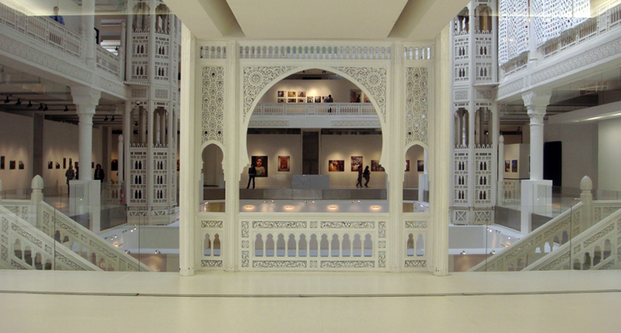

http://mama-dz.com/musee/museePhoto

With the exception of Egypt, until the late 1990s, there were relatively few state-run or public modern art spaces in North Africa. Those few museums that exhibited modernist works, such as the National Museum of Fine Arts in Algiers (founded in 1897), exhibited painting primarily by Europeans and European settlers. In Morocco, six artists from the Casablanca School (an art collective that emerged from the Casablanca Fine Arts Academy in the early 1960s) attempted to counter this dynamic by educating the local public about modernist art through large-scale exhibits in squares and marketplaces, and Moroccan cultural journals *Souffles* and *Integral* published reproductions of modern art from across the region and the Middle East. During this time, artists from across the region organized exchange exhibits and art festivals with colleagues in Iraq, Syria and Lebanon, but due to the political environments across the region, many artists lived and practiced in Europe. This was the case for the majority of modernist artists from Libya. In Egypt, there was more state-support of modern art than in other North African countries with numerous state-run galleries and museums serving Egyptian artists. For example, building on the work of Mohamed Mahmoud Khalil and the Society of the Friends of Art, the Museum of Modern Egyptian Art in Cairo was officially founded in 1931 with 584 works of art. . Private collections were also more expansive in Egypt than in neighboring North African countries. In the 1990s numerous galleries and independent art spaces devoted to modern and contemporary art opened and flourished in the region. The most notable are the Galerie Ammar Farhat (1988) and the Galerie el Marsa (1994) in Tunisia, the Townhouse Gallery in Cairo (1998), and the Villa des arts in Casablanca (1999). In 2013, Morocco and Tunisia were completing work on two large-scale museums of modern art in their capitals.

**References and further reading:**

Pieprzak, K. (2010) *Imagined Museums: Art and Modernity in Post-Colonial Morocco*, Minneapolis MN: University of Minnesota Press (Cultural history of museums and modern art in Morocco from 1912-2007).

Vogl, M. (2013) “Algerian Painters as Pioneers of Modernism” in *A Companion to Modern African Art*, Salami and Blackmun ed. London: John Wiley & Sons, Inc. 2013 (Article that explores the history of modernism in North Africa with a focus on Algeria).

Winegar, J. (2006) *Creative Reckonings: The Politics of Art and Culture in Contemporary Egypt*, Stanford California: Stanford University Press (While focused on the 1990s, this book traces the politics and relationships of art and culture and Egyptian institutions throughout the twentieth century).